**Flashcard Application - Maria and her Minions**

# Group Members

|  |  |
| --- | --- |
| **Name** | **Admission Number** |
| Maria Muwale | 192414 |
| Nathan Achar | 189206 |
| Githinji Mugambi | 189596 |
| Allan Waithaka | 191604 |
| Faith Muthoni | 178509 |

# What exactly does our project do?

Our project implements a flashcard study tool that mimics how learners use revision cards — flipping through them, going back, tagging useful ones, and dynamically updating the collection. We used four key data structures — linked list, queue, stack, and hash map — to model this behavior. MongoDB was used to store flashcards in the cloud.

# Which structures did we use and why?

|  |  |  |
| --- | --- | --- |
| **Data Structure** | **Usage** | **Why We Used It** |
| Linked List | Flashcard storage in memory | Dynamic and flexible add/edit/delete |
| Queue | Review flow (FIFO order) | Mimics normal flashcard flow |
| Stack | Flip-back or 'undo' feature | Follows LIFO for card history |
| Hash Map | Bookmarks & tag-based lookup | Allows instant access to key cards |

# Which technologies were used to achieve our project?

* Python 3
* MongoDB Atlas (NoSQL cloud database)
* pymongo (MongoDB Python driver)
* Git & GitHub (collaboration & version control)
* Tkinter GUI

# Which group member handled which module?

* Maria Muwale – Queue (Review Flow)
* Created FlashcardQueue class using doubly-linked Nodes
* Implemented enqueue, dequeue, peek, and display methods
* Faith Muthoni – Stack (Flip History)
* Created FlashcardStack class with push, pop, and peek
* Integrated stack updates into the review loop for backtracking
* Tracked previously reviewed flashcards for LIFO-based undo
* Githinji Mugambi – Hash Map (Bookmarks) + Review History
* Designed dictionary-based tag/bookmark system for cards
* Linked cards to topics or 'starred' labels
* Enabled instant retrieval of bookmarked cards
* Enabled the ability to review history
* Nathan Achar – Linked List (Card Storage) + MongoDB
* Built the LinkedList and Node classes for dynamic card management
* Enabled addition, editing, and deletion of flashcards
* Served as the backbone for queue and stack modules
* Set up MongoDB database for storage of data in a cloud platform
* Allan Waithaka – Interface + Integration
* Built the CLI menu to allow user interaction
* Integrated all modules: database, queue, stack, bookmarks
* Tested end-to-end functionality and handled edge cases

# Time and Space Complexity Summary

|  |  |  |  |
| --- | --- | --- | --- |
| **Data Structure** | **Operation** | **Time Complexity** | **Space Complexity** |
| Queue | Enqueue | O(1) | O(1) |
| Dequeue | O(1) | O(1) |
| Peek | O(1) | O(1) |
| Show All | O(n) | O(1) |
| Stack | Push | O(1) | O(1) |
| Pop | O(1) | O(1) |
| Peek | O(1) | O(1) |
| Linked List | Add Card | O(1) | O(1) |
| Edit/Delete/Search | O(n) | O(1) |
| Display All | O(n) | O(1) |
| Hash Map | Add Bookmark | O(1) | O(1) |
| Remove Bookmark | O(1) | O(1) |
| Lookup Bookmark | O(1) | O(1) |
| Get All Bookmarks | O(k) | O(k) |

# Steps for running the project

1. Ensure you have python 3 installed, a stable internet connection and MongoDB in the main file. If you don't have MongoDB, run pip install pymongo.
2. Run the program in the gui1.py file, which is in the ui folder.

# References

Python Tkinter - GeeksforGeeks <https://share.google/auR7N0TiMX3kKpDKx>

<https://cloud.mongodb.com/v2/686543a330bb7741eb21af3c#/explorer/686622ee77ada12f30b63504/flashcard_app/flashcards/find>

# Screenshots

1. Adding a flashcard

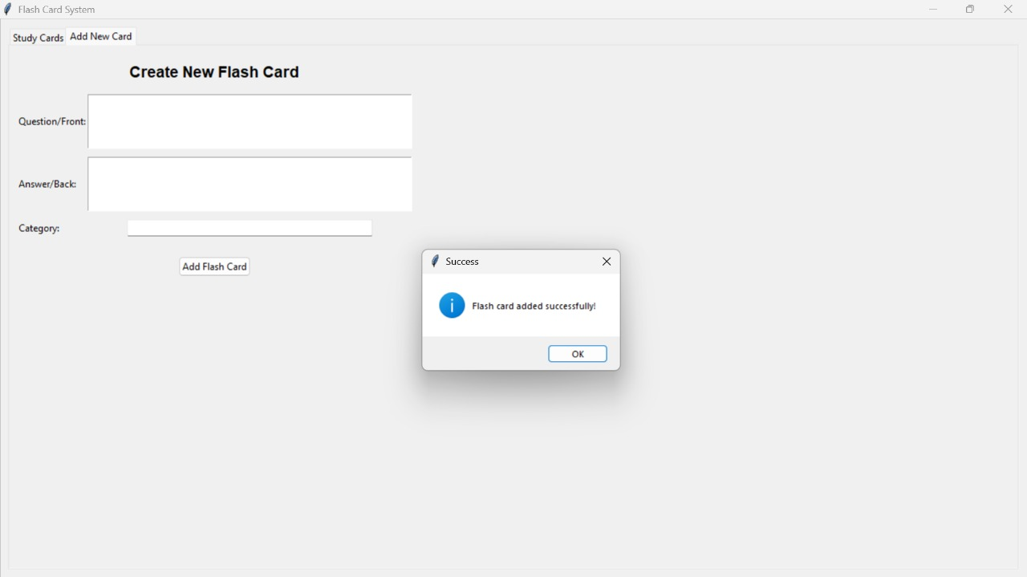

1. Viewing the flashcard

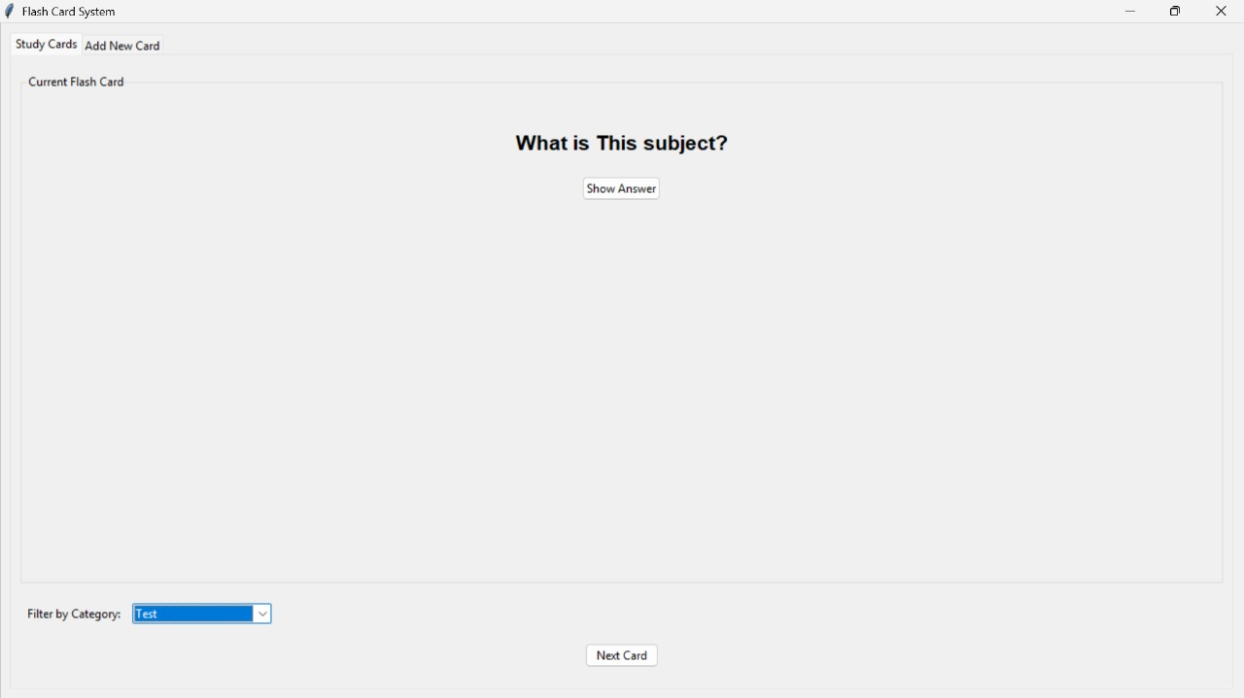

1. Viewing the categories/bookmarks

1. Review history